Day 3 of Week 1 (Prepare Storage and Install the AD DS Role) is the preparation step between having a running VM and promoting it to a domain controller. Its purpose is to get the server ready so the next day's promotion is clean.
Three things happen:
- Format the data disk as F: — initialize, partition, and format the separate 32GB disk you attached on Day 2, so the AD database (NTDS.dit), logs, and SYSVOL have their own dedicated drive instead of sitting on the OS disk.
- Install the AD DS role — add the Active Directory Domain Services Windows feature (Install-WindowsFeature), which installs the software and management tools but does not create a domain yet.
- Read ahead through the next day's Install-ADDSForest parameters so you understand each one before running it live.
The key "why" is the separate disk: keeping the AD database off the OS disk is real production best practice (per Microsoft's guidance), not a lab shortcut, and it's a detail interviewers use to tell whether someone actually understands AD internals. So Day 3 is the "lay the storage foundation and install the role, but don't promote yet" day — everything that makes Day 4's forest creation succeed on the first try.
Keeping the AD database (NTDS.dit), logs, and SYSVOL on their own disk instead of the OS disk matters for a few real reasons:
Performance. AD is a database, and it's constantly reading and writing — especially the transaction logs. If that write activity shares a disk with the OS (which is also busy paging, logging, and running Windows), they compete for the same disk I/O and both slow down. A separate disk lets AD's writes not fight the operating system's.
Recoverability and safety. If the OS disk fills up or gets corrupted, you don't want it taking the AD database down with it — and vice versa. A runaway log or a full OS drive is a common real-world cause of a DC going unhealthy. Separating them means a problem on one disk doesn't automatically become a problem on the other. It also makes backup/restore of just the AD data cleaner.
Write caching correctness. Microsoft's guidance for AD DS on Azure VMs specifically calls for putting the database on a data disk with host caching set to None (or read-only). The OS disk uses caching that can lie to AD about whether a write actually hit the disk — and AD is very sensitive to that, because a lost write can corrupt the directory. A dedicated data disk lets you set the caching mode AD actually needs without disturbing OS performance.
It's the production standard, not a lab formality. This is the part that matters for your interviews: doing it the "real" way signals you understand AD internals rather than just clicking through a wizard on defaults. It's a detail experienced interviewers sometimes probe for exactly that reason.
So the short version: separate disk = better performance, safer recovery, correct write handling for the database, and it's how it's genuinely done in production. That's why Day 3 sets up F: before Day 4 points the database, logs, and SYSVOL paths at it during promotion.

Day 3 - Prepare Storage and Install the AD DS Role
1. **Bring the data disk online, partition, and format it as `F:`**
```powershell
# Confirm the raw data disk is visible (should show as Offline, RAW)
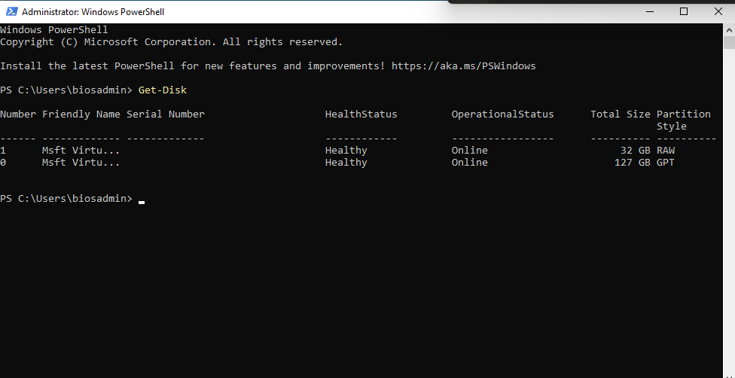
Initialize-Disk -Number 2 -PartitionStyle GPT
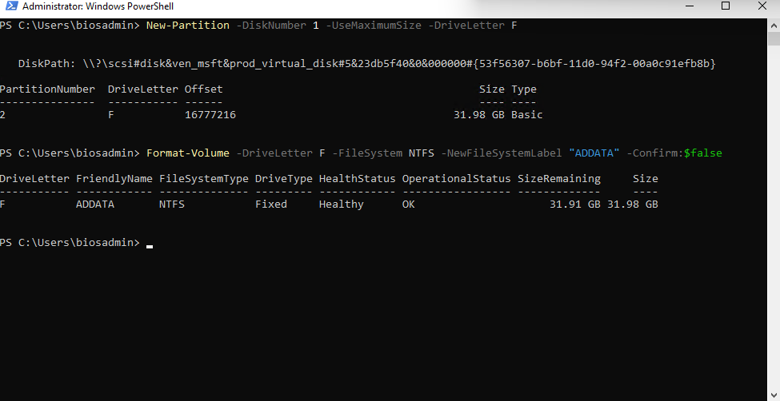
# Confirm it's online and healthy
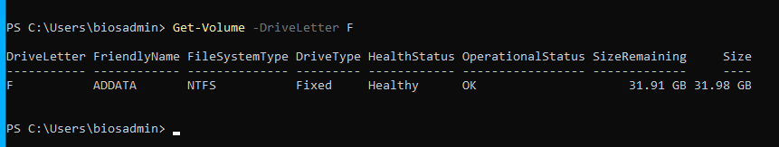

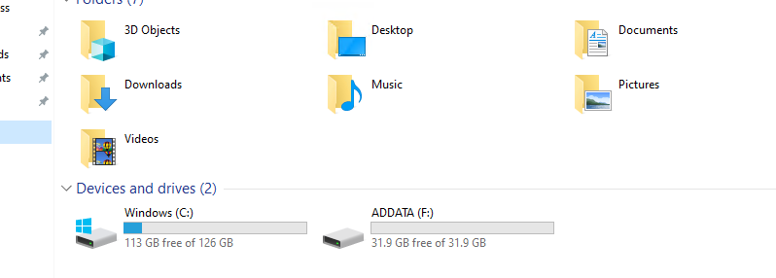
2. **Install the AD DS role**
